**LAB FAT- TUESDAY- SET 1**

**Prof. Nancy Victor**

Consider the following relations for a movie database application:

Movie(mid, name, dateofrelease, aid)

Actor(aid, name, rating)

Theatre(tid, mid, aid, location, phone, name)

Ticket(ttid, type, tid, price)

----------------------------------------------------------------------------------------------------------------**Q1) Create tables as shown above.**

**A1) CREATE TABLE SCREENSHOTS:**

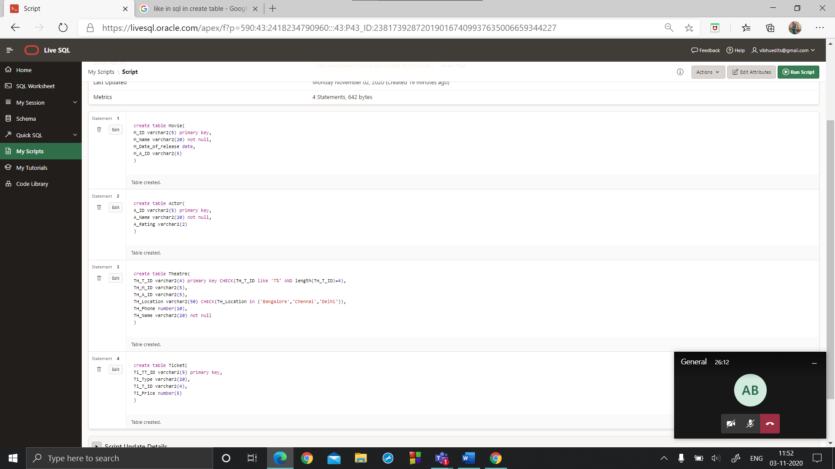

CODE:

create table Movie(

M_ID varchar2(5) primary key,

M_Name varchar2(20) not null,

M_Date_of_release date,

M_A_ID varchar2(5)

);

create table Actor(

A_ID varchar2(5) primary key,

A_Name varchar2(20) not null,

A_Rating varchar2(2)

);

create table Theatre(

TH_T_ID varchar2(4) primary key CHECK(TH_T_ID like 'T%' AND length(TH_T_ID)=4),

TH_M_ID varchar2(5),

TH_A_ID varchar2(5),

TH_Location varchar2(50) CHECK(TH_Location in ('Bangalore','Chennai','Delhi')),

TH_Phone number(10),

TH_Name varchar2(20) not null

);

create table Ticket(

Ti_TT_ID varchar2(5) primary key,

Ti_Type varchar2(20),

Ti_T_ID varchar2(4),

Ti_Price number(5)

);

FOREIGN KEYS:

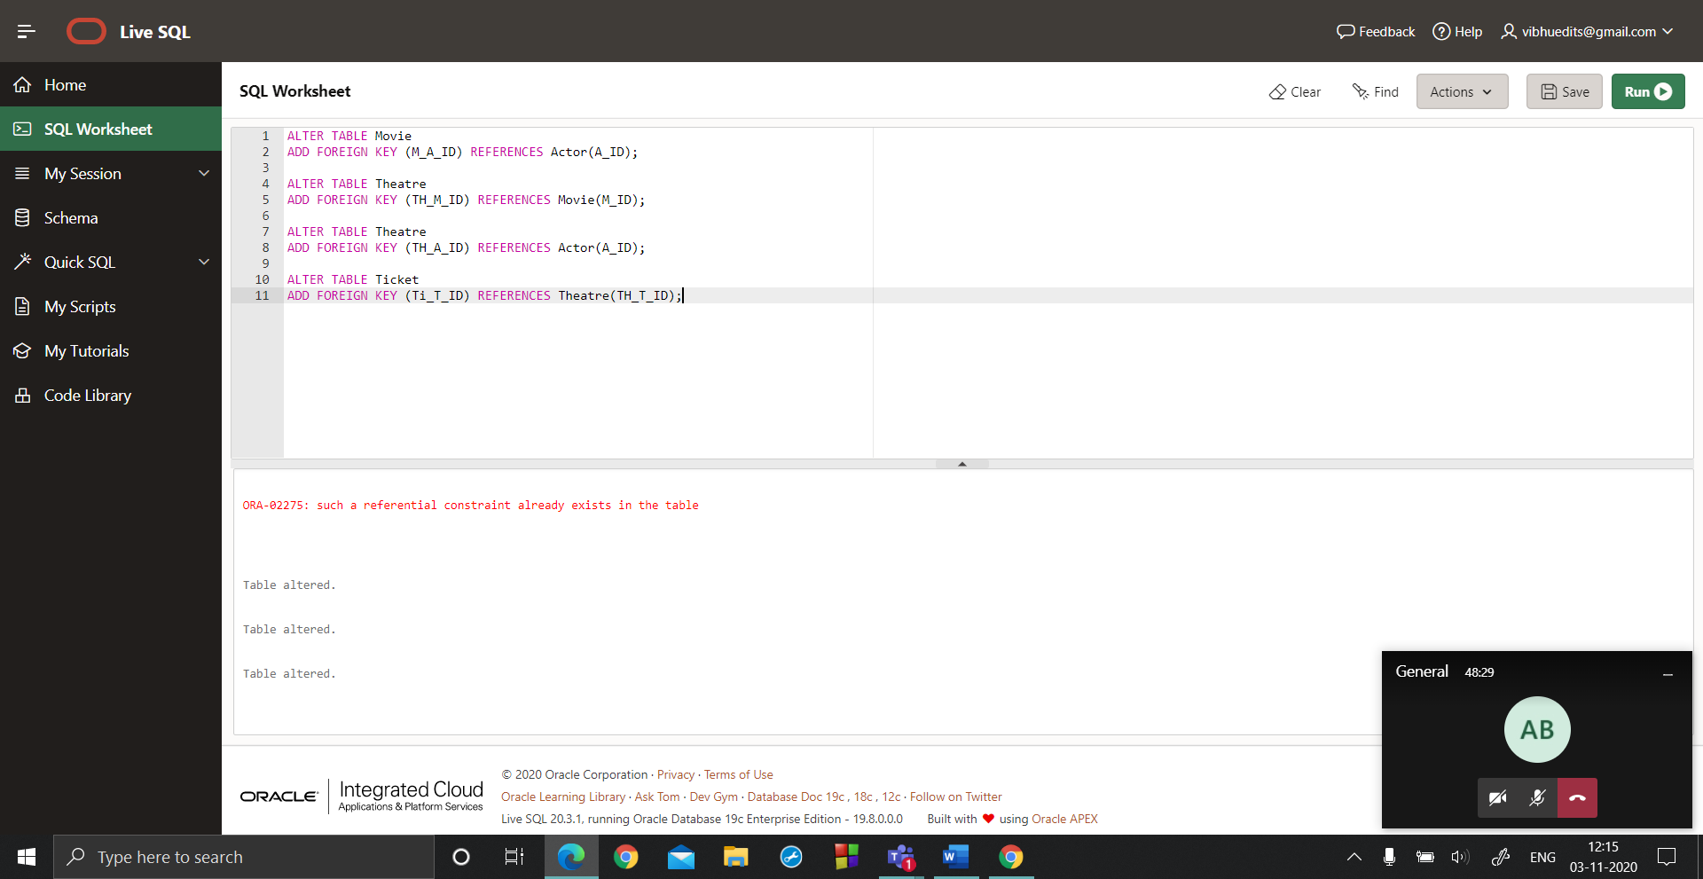

**Q2) Add a new attribute named “budget” to the table “Movie”.**

**A2)**

Alter table Movie add budget float(5);

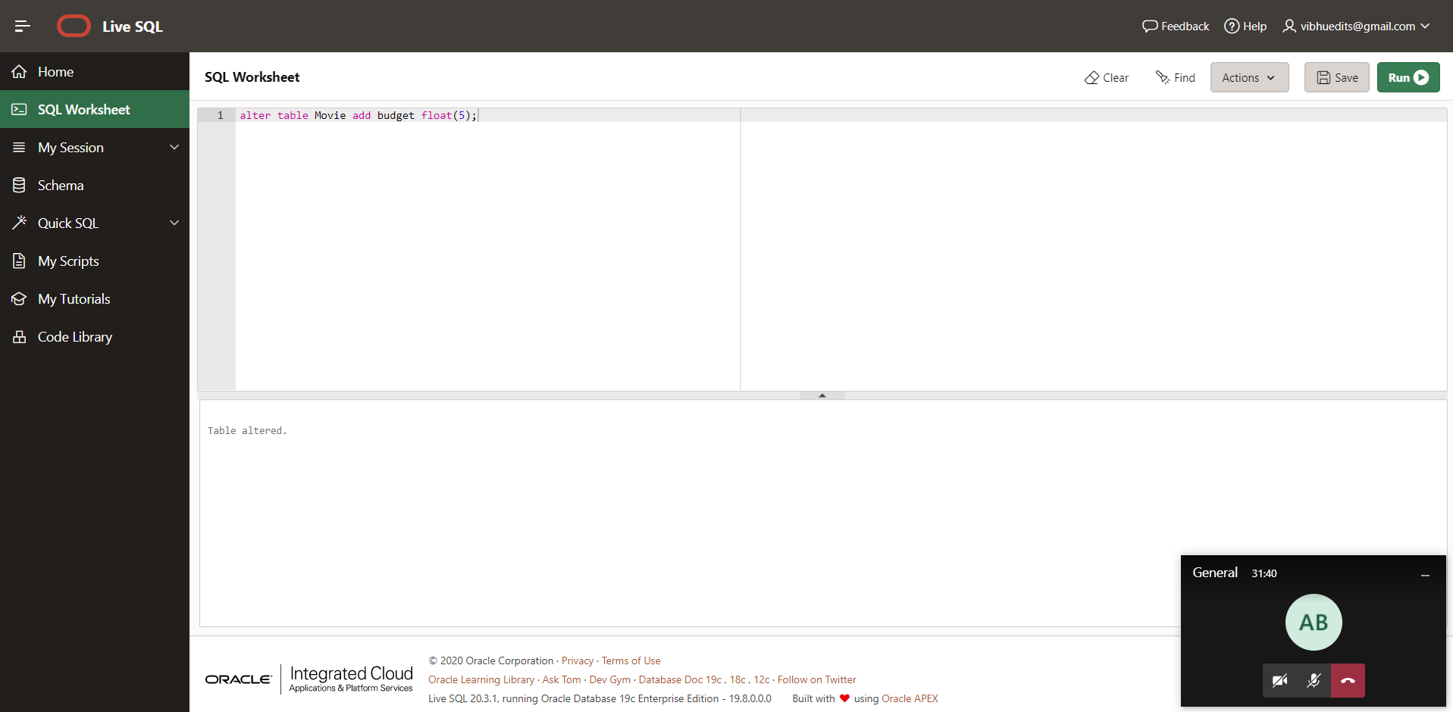

**Q3) Populate the table as given below:**

**A3)**

insert into Movie values('M1','Dreams',TO_DATE('21/10/2018','DD/MM/YYYY'),'A1',21.1);

insert into Movie values('M2','Love',TO_DATE('22/05/2019','DD/MM/YYYY'),'A2',40.2);

insert into Movie values('M3','World',TO_DATE('25/05/2020','DD/MM/YYYY'),'A4',50);

insert into Movie values('M4','Happiness',TO_DATE('30/10/1995','DD/MM/YYYY'),'A5',2.5);

insert into Actor values('A1','Bob',4);

insert into Actor values('A2','Alice',3);

insert into Actor values('A3','James',1);

insert into Actor values('A4','Jacob',4);

insert into Actor values('A5','Paul',3);

insert into Theatre values('T001','M1','A1','Bangalore',123456,'Agni');

insert into Theatre values('T002','M2','A3','Chennai',234567,'Jwala');

insert into Theatre values('T003','M3','A2','Delhi',345678,'Universe');

insert into Theatre values('T004','M4','A4','Chennai',567891,'Fortune');

insert into Ticket values('T1','VIP','T001',500);

insert into Ticket values('T2','VVIP','T002',1000);

insert into Ticket values('T3','VIP','T003',400);

insert into Ticket values('T4','VIP','T002',600);

insert into Ticket values('T5','VVIP','T004',1500);

**Q4) Modify the rating of the actor “Alice” to 4.**

**A4)**

update Actor SET A_Rating=4 WHERE A_Name='Alice';

select * from Actor;

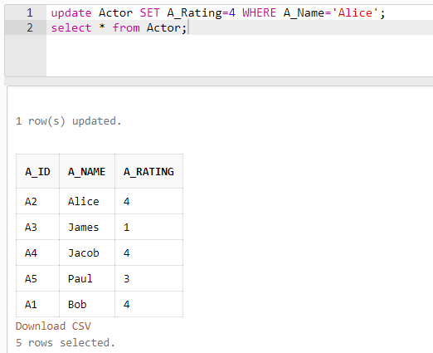

**Q5) Display the details of all tables with values.**

**A5)**

Select * from Movie;

Select * from Actor;

Select * from Theatre;

Select * from Ticket;

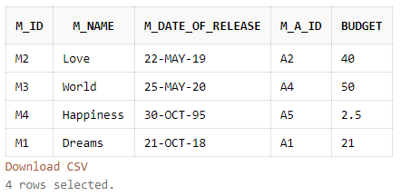

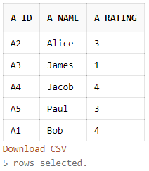

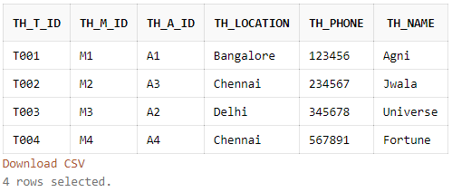

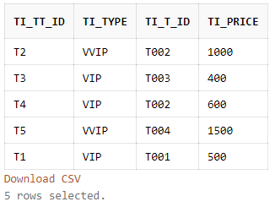

**Q6) Display the actor details in the ascending order of rating.**

**A6)**

select * from Actor order by A_Rating;

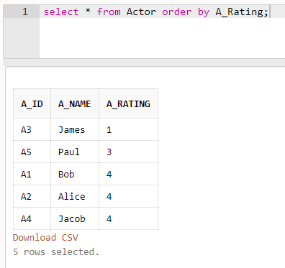

**Q7) Display the types of tickets available in the theatre “Jwala”.**

**A7)**

select Ti_Type from Ticket INNER JOIN Theatre ON Ticket.Ti_T_ID=Theatre.TH_T_ID WHERE Theatre.TH_Name='Jwala';



**Q8) Find the movie names and date of release of all movies by the actors with a rating greater than or equal to 3. (Use subqueries).**

**A8)**

select Movie.M_Name,Movie.M_Date_of_release from Movie WHERE Movie.M_A_ID in(select Actor.A_ID from Actor WHERE Actor.A_Rating>3);

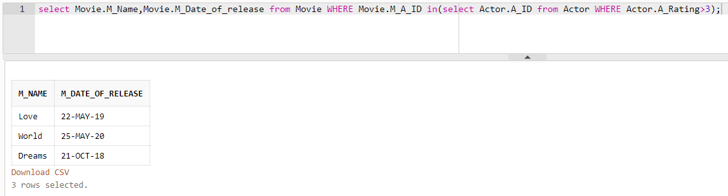

**Q9) Display the theatre id, location and phone number of theatres with the name starting with the letter “A”.**

**A9)**

select TH_T_ID,TH_Location,TH_Phone from Theatre WHERE TH_Name like 'A%';

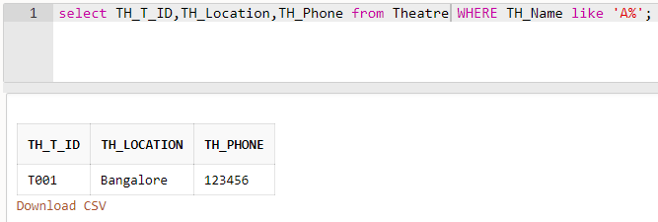

**Q10) Display the details of theatres where the movies by the actor “Jacob” are played. (Use joins).**

**A10)**

select * from Theatre INNER JOIN Actor ON Theatre.TH_A_ID=Actor.A_ID WHERE Actor.A_Name='Jacob';



**Q11) Use PL/SQL to display the date of release and budget of the movie “Love”.**

**A11)**

create or replace Procedure MovDet(MovName Movie.M_Name%type) is

MovBudget Movie.budget %type;

MovDor Movie.M_Date_of_release %type;

begin

select M_Date_of_release,budget into MovDor,MovBudget from movie where M_Name = MovName;

dbms_output.put_line('Name: '||MovName);

dbms_output.put_line('Date Of Release: '||MovDOR);

dbms_output.put_line('Budget: '||MovBudget);

exception

when no_data_found then

dbms_output.put_line ('no data found');

end;

